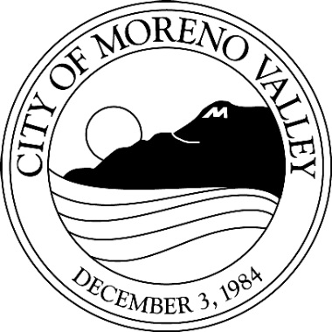

Notice of

PUBLIC HEARING

This may affect your property. Please read.
Notice is hereby given that a Public Hearing will be held by the Planning Commission of the City of Moreno Valley on the following item(s):

Project: P16-007 (Variance) and P16-008 (Variance)
Applicant: Riverside Housing Development Corp (RHDC)
Owner: Riverside Housing Development Corp (RHDC)
Representative: Riverside Housing Development Corp (RHDC)
A.P. No(s): 291-293-009 & 291-293-010
Location: 22889 Allies Pl and 22899 Allies Pl

Proposal: The variance request is to reduce the rear setback to 5 feet, allowing the applicant to build four one-car garages, storage space and laundry room to two existing four unit apartment complexes. There will be approximately 10 feet between alley and face of garage in order to provide adequate sight distance. The project site is located within a Residential 20 (R20) zoning district.

Council District: 5
Case Planner: Claudia Manrique

The proposed project includes reducing the rear setback from 25 to 5 feet, allowing the applicant to build four one-car garages, storage space and laundry room to two existing four unit apartment complexes. The exterior and interior of the existing structures will be remodeled as well.

As proposed, the project will not have a significant effect on the environment, and is therefore exempt from the provisions of the California Environmental Quality Act (CEQA) as a Class 5 Categorical Exemption, CEQA Guidelines, as provided for in Section 15305 (Minor Alterations in Land Use Limitation).

Any person interested in the proposal may speak at the hearing or provide written testimony at or prior to the hearing. The application file and environmental documents may be inspected at the Community Development Department at 14177 Frederick Street, Moreno Valley, California during normal business hours (7:30 a.m. to 5:30 p.m., Monday through Thursday and 7:30 a.m. to 4:30 p.m., Friday), or you may telephone (951) 413-3206 for further information.

Any person may also appear and be heard in support or in opposition of the project and/or recommended environmental determination at the time of hearing.

The Planning Commission may consider an appropriate modification or alternative to the project or the environmental determination. If you challenge this item in court, you may be limited to raising only those issues you or someone else raised at the Public Hearing described in this notice, or in written correspondence delivered to the Planning Commission at, or prior to, the Public Hearing.

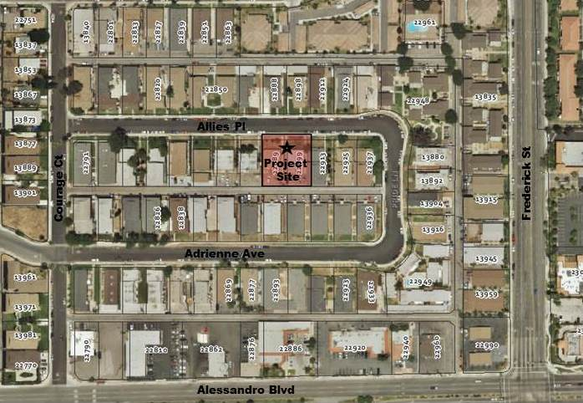

LOCATION N

PLANNING COMMISSION HEARING

City Council Chamber, City Hall
14177 Frederick Street
Moreno Valley, Calif. 92553

DATE AND TIME: April 28, 2016 at 7 PM

CONTACT PLANNER: Claudia Manrique

PHONE: (951) 413-3225

