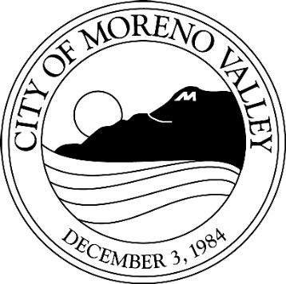

Notice of

PUBLIC HEARING

This may affect your property. Please read.
Notice is hereby given that a Public Hearing will be held by the Planning Commission of the City of Moreno Valley on the following item(s):

CASE: PA15-0005 Conditional Use Permit

P15-092 Variance

APPLICANT: VZW/Cortel

OWNER: Southern California Edison

REPRESENTATIVE: Andrea Urbas

A.P.N.: 486-070-018

LOCATION: Southwest corner of Kitching Street and John F. Kennedy Drive

PROPOSAL: Conditional Use Permit PA15-0005 and Variance P15-092 application for a 58 foot tall telecommunications facility and equipment on 24.23 acres. The proposed installation will have the appearance of a pine tree. The variance application is for a 35 foot setback from the east property line. The zoning is R5.

ENVIRONMENTAL DETERMINATION: Class 3 Categorical Exemption

COUNCIL DISTRICT: 4

STAFF RECOMMENDATION:
The project is exempt from the provisions of the California Environmental Quality Act (CEQA) as a Class 3 Categorical Exemption, CEQA Guidelines, Section 15303 for New Construction or Conversion of Small Structures.

Any person interested in any listed proposal can contact the Community Development Department, Planning Division, at 14177 Frederick St., Moreno Valley, California, during normal business hours (7:30 a.m. to 5:30 p.m., Monday-Thursday and 7:30 a.m. to 4:30 p.m. on Fridays), or may telephone (951) 413-3206 for further information. The associated documents will be available for public inspection at the above address.

In the case of Public Hearing items, any person may also appear and be heard in support of or opposition to the project or recommendation of adoption of the Environmental Determination at the time of the Hearing.

The Planning Commission, at the Hearing or during deliberations, could approve changes or alternatives to the proposal.

If you challenge any of these items in court, you may be limited to raising only those items you or someone else raised at the Public Hearing described in this notice, or in written correspondence delivered to the Planning Commission at, or prior to, the Public Hearing.

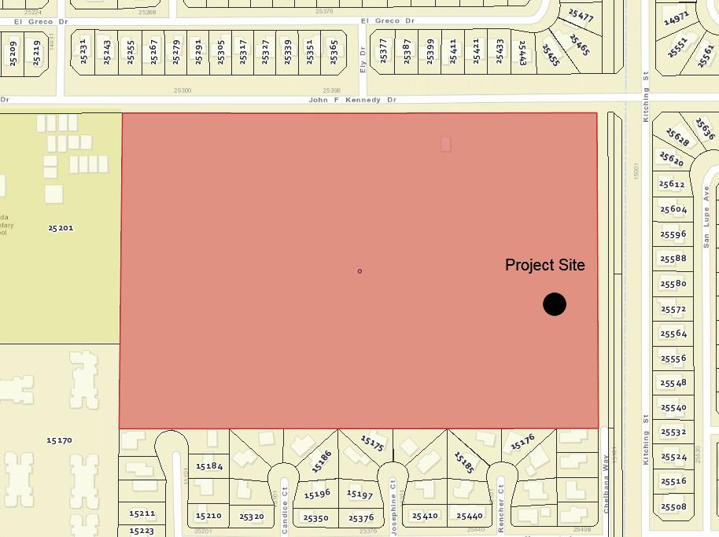

LOCATION N

PLANNING COMMISSION HEARING

City Hall Council Chamber
14177 Frederick Street
Moreno Valley, Calif. 92553

DATE AND TIME: May 26, 2016 at 7 PM

CONTACT PLANNER: Gabriel Diaz

PHONE: (951) 413-3226

