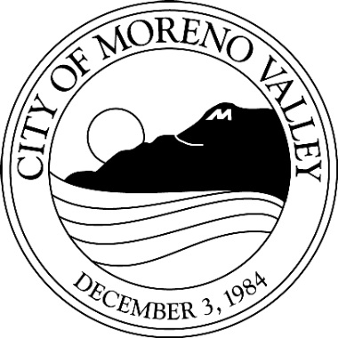

This may affect your property

Notice of

PUBLIC HEARING

Notice is hereby given that a Public Hearing will be held by the City Council of the City of Moreno Valley on the following item(s):

Project: PEN16-0092 (PA16-0018) – General Plan Amendment
PEN16-0093 (PA16-0019) – Zone Change
PEN16-0094 (PA14-0052) – Conditional Use Permit
PEN16-0095 (PA14-0053) – TTM 36760

Applicant: Mission Pacific Land Company
Owner: MPLC Legacy 75 Associates, LP
Representative: Rick Engineering Company
A.P. No: 485-220-023, -032, and -040
Location: Southeast corner Gentian Avenue and Indian Street
Proposal: General Plan Amendment from Residential 30 to Residential 5 and Zone Change from R30 to R5 for a 15.06 acre portion of a 53 acre site. This project includes Tentative Tract Map 36760 to subdivide the 53 acre site into a total of 221 single family residential lots and a Conditional Use Permit for a Planned Unit Development (PUD). The PUD application will establish minimum lot sizes of 4,000 and 5,000 square feet and establish unique lot widths and setback standards along with architectural guidelines.
Council District: 4

The project has been evaluated against criteria set forth in the California Environmental Quality Act (CEQA) Guidelines and it was determined that the project will not have the potential for a significant effect on the environment with the incorporation of mitigation measures. A Mitigated Negative Declaration is recommended. Mitigation measures have been required of the project that will reduce potential impacts to a less than significant level.

A public hearing before the City Council has been scheduled for the proposed project. Any person interested in commenting on the proposal and recommended environmental determination may speak at the hearing or provide written testimony at or prior to the hearing. The project application, supporting plans and environmental documents may be inspected at the Community Development Department at 14177 Frederick Street, Moreno Valley, California during normal business hours (7:30 a.m. to 5:30 p.m., Monday through Thursday and 7:30 a.m. to 4:30 p.m., Friday), or you may telephone (951) 413-3206 for further information.

The City Council, at the Hearing or during deliberations, could approve changes or alternatives to the proposal. If you challenge any of these items in court, you may be limited to raising only those items you or someone else raised at the Public Hearing described in this notice, or in written correspondence delivered to the City Council at, or prior to, the Public Hearing.

LOCATION N

CITY COUNCIL HEARING

City Council Chamber, City Hall
14177 Frederick Street
Moreno Valley, Calif. 92553

DATE AND TIME: March 21, 2017, 6:00 p.m.

CONTACT PLANNER: Jeff Bradshaw

PHONE: (951) 413-3224

Upon request and in compliance with the Americans with Disabilities Act of 1990, any person with a disability who requires a modification or accommodation in order to participate in a meeting should direct such request to Guy Pegan, ADA Coordinator, at 951.413.3120 at least 48 hours before the meeting. The 48-hour notification will enable the City to make reasonable arrangements to ensure accessibility to this meeting.

