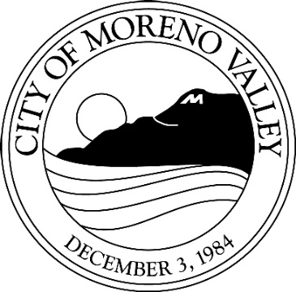
Notice of

PUBLIC HEARING

This may affect your property. Please read.
Notice is hereby given that a Public Hearing will be held by the City Council of the City of Moreno Valley on the following item(s):

Project: PEN16-0001 Specific Plan Amendment
PEN16-0002 Environmental Impact Report
PEN16-0003-PEN16-0006 Plot Plans
PEN16-0007 Tentative Parcel Map
Applicant: Prologis
Owner: Moorpark Country Properties
Representative: Scott Mulkay
A.P. No(s): 316-100-028, 030 and portions of 052
Location: Krameria Avenue south to Cardinal
Avenue between Heacock Street and
Indian Street
Proposal: The project includes: 1) Specific Plan Amendment to modify land use buffering and landscape requirements; Tentative Parcel Map 36150 to consolidate 73.4-are from three parcels into two, and 3) four Plot Plans for a warehouse distribution center with four buildings ranging in size from 97,222 square feet to 1.3 million square feet with a combined 1,737,518 square feet of total floor space, associated site development (e.g. access, parking, landscape, walls). The project site is vacant and in the Moreno Valley Industrial Area Specific Plan 208. Approval of the project will require the certification of an Environmental Impact Report.

COUNCIL DISTRICT: 4

STAFF RECOMMENDATION: Approval

Any person interested in any listed proposal can contact the Community Development Department, Planning Division, at 14177 Frederick St., Moreno Valley, California, during normal business hours (7:30 a.m. to 5:30 p.m., Monday through Thursday and 7:30 a.m. to 4:30 p.m. on Fridays), or may telephone (951) 413-3206 for further information. The associated documents will be available for public inspection at the above address.

In the case of Public Hearing items, any person may also appear and be heard in support of or opposition to the project or recommendation of adoption of the Environmental Determination at the time of the Hearing.

The City Council, at the Hearing or during deliberations, could approve changes or alternatives to the proposal.

If you challenge any of these items in court, you may be limited to raising only those items you or someone else raised at the Public Hearing described in this notice, or in written correspondence delivered to the City Council at, or prior to, the Public Hearing.
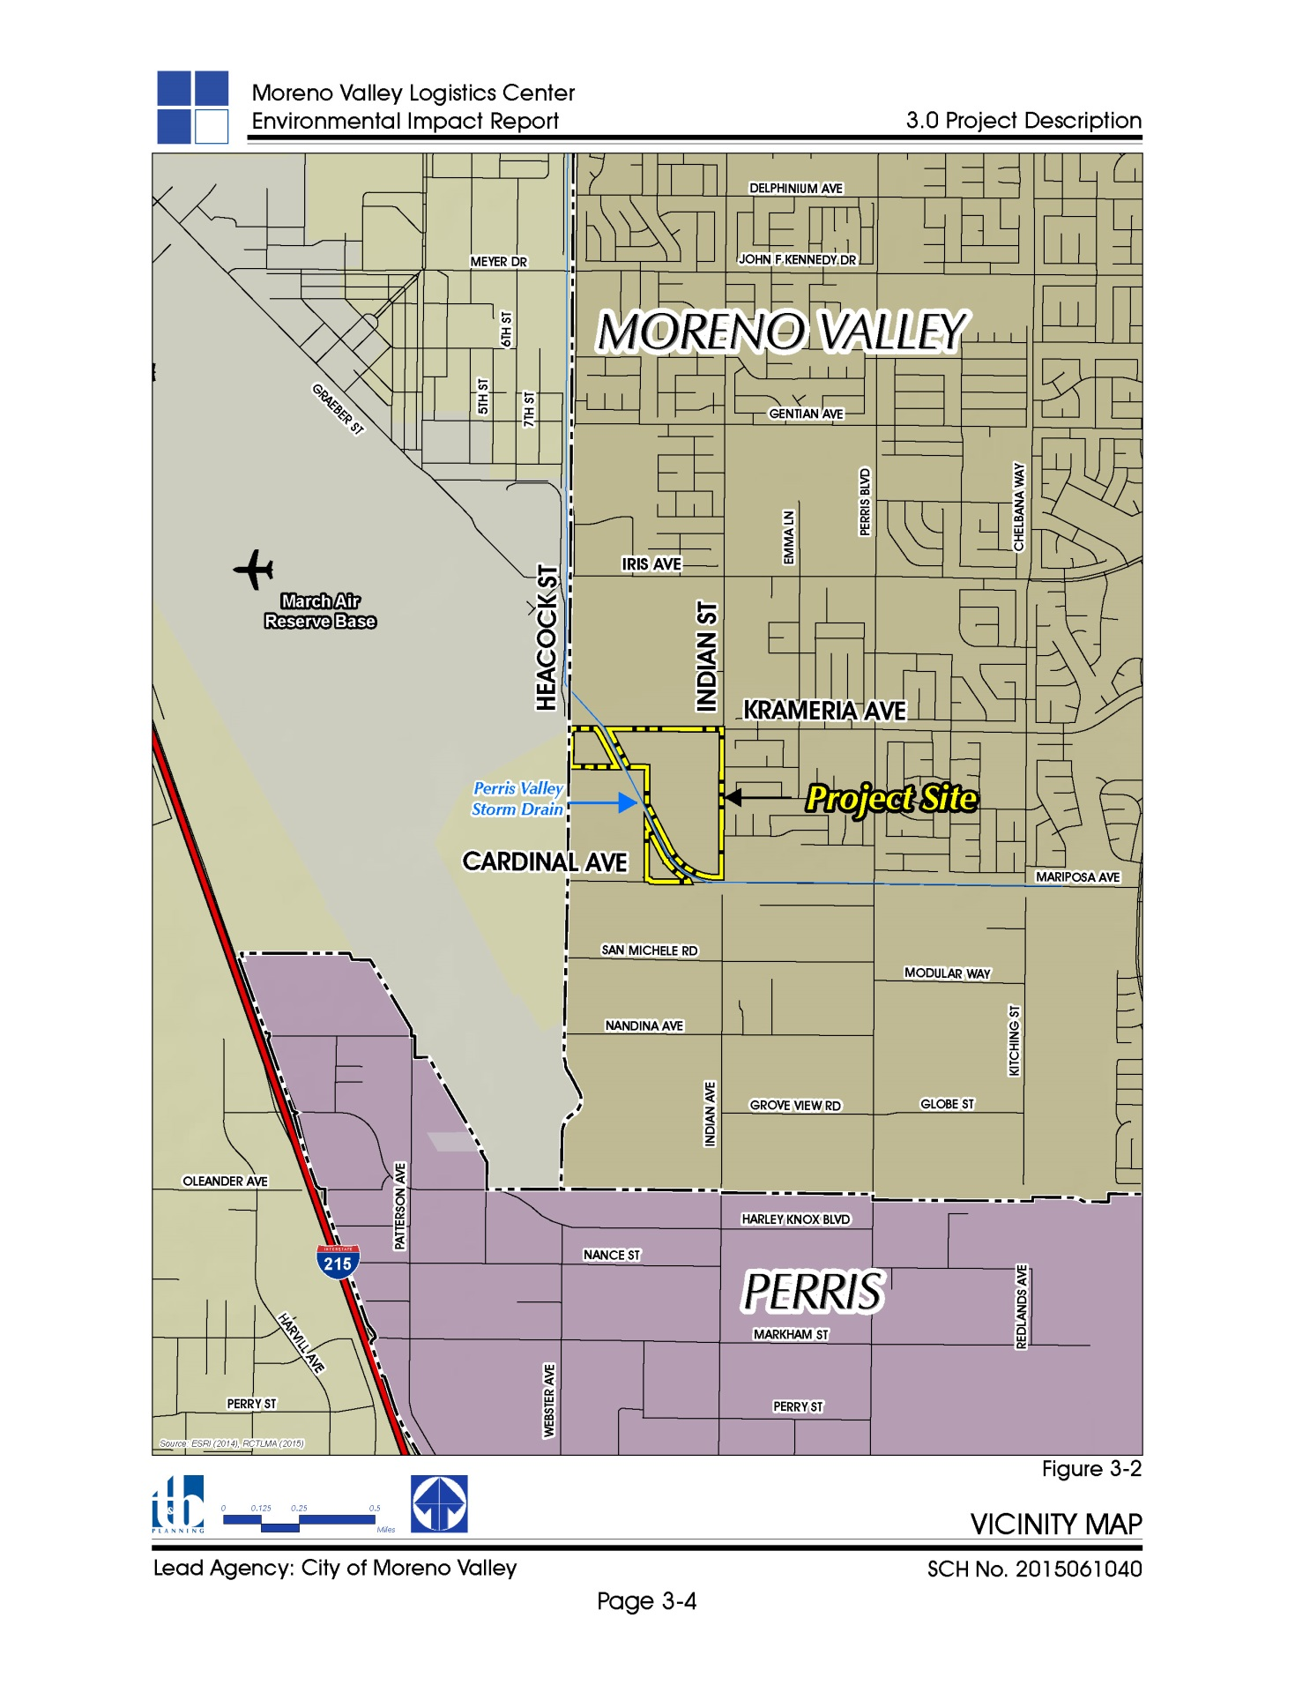

LOCATION N

CITY COUNCIL HEARING

City Hall Council Chamber

14177 Frederick Street
Moreno Valley, Calif. 92553

DATE AND TIME: September 5, 2017 at 6PM

CONTACT PLANNER: Julia Descoteaux

PHONE: (951) 413-3206

