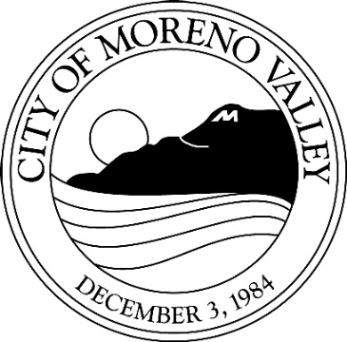
Notice of

PUBLIC HEARING

This may affect your property. Please read.
Notice is hereby given that a Public Hearing will be held by the City Council of the City of Moreno Valley on the following item(s):

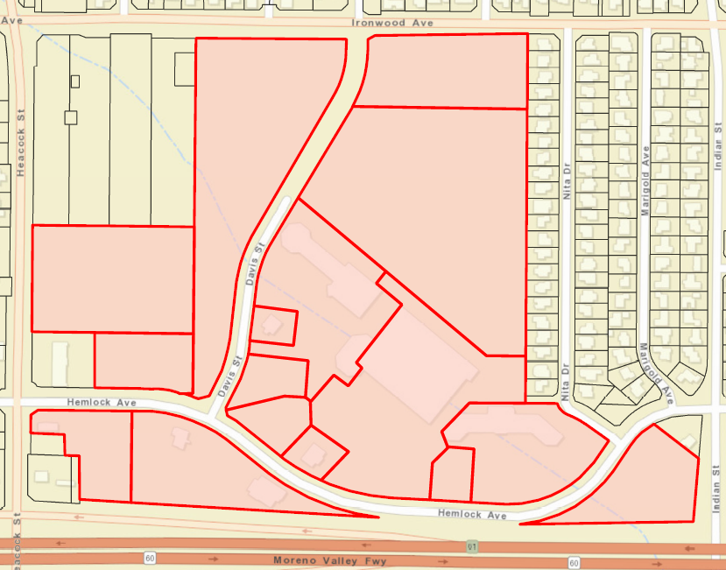
CASE: PEN16-0015 Specific Plan Amendment
PEN16-0013 General Plan Amendment
PEN16-0014 Change of Zone

APPLICANT: LCG MVF, LLC
OWNER: Joseph E. Miller, Moreno Valley Festival, LTD

REPRESENTATIVE: LCG MVF, LLC
LOCATION: Easterly of Heacock Street between Ironwood Avenue and State Highway 60

PROPOSAL: A Specific Plan amendment to modify the existing Festival Specific Plan 205 (SP205) proposing a wider range of land uses and development opportunities. Proposed land uses include commercial, retail, business park including warehousing, office and medical. The proposal will connect Davis Street from Ironwood Avenue south to Hemlock Avenue. A General Plan Amendment and Change of Zone are required for consistency between the City’s General Plan and Zoning Atlas.
Heacock St

ENVIRONMENTAL DETERMINATION: Mitigated Negative Declaration

COUNCIL DISTRICT: 1

STAFF RECOMMENDATION: Approval

Any person interested in any listed proposal can contact the Community Development Department, Planning Division, at 14177 Frederick St., Moreno Valley, California, during normal business hours (7:30 a.m. to 5:30 p.m., Monday through Thursday and 7:30 a.m. to 4:30 p.m. on Fridays), or may telephone (951) 413-3206 for further information. The associated documents will be available for public inspection at the above address.

In the case of Public Hearing items, any person may also appear and be heard in support of or opposition to the project or recommendation of adoption of the Environmental Determination at the time of the Hearing.

The City Council, at the Hearing or during deliberations, could approve changes or alternatives to the proposal.

If you challenge any of these items in court, you may be limited to raising only those items you or someone else raised at the Public Hearing described in this notice, or in written correspondence delivered to the City Council at, or prior to, the Public Hearing.
Ironwood Ave

Davis St

Hemlock Ave

LOCATION N

CITY COUNCIL HEARING

City Hall Council Chamber

14177 Frederick Street
Moreno Valley, Calif. 92553

DATE AND TIME: April 17, 2018 at 6:00 PM

CONTACT PLANNER: Chris Ormsby, AICP

PHONE: (951) 413-3229

