RESOLUTION NO. CSD 2019-__

A RESOLUTION OF THE MORENO VALLEY COMMUNITY SERVICES DISTRICT OF THE CITY OF MORENO VALLEY, CALIFORNIA, APPROVING AN ENGINEER’S REPORT IN CONNECTION WITH THE FISCAL YEAR 2019/20 ASSESSMENTS AGAINST REAL PROPERTY IN MORENO VALLEY COMMUNITY SERVICES DISTRICT LANDSCAPE MAINTENANCE DISTRICT NO. 2014-02

WHEREAS, pursuant to Government Code Section 61122(e), the Moreno Valley Community Services District (the “CSD”) is authorized to levy benefit assessments for operations and maintenance pursuant to the Landscaping and Lighting Assessment Act of 1972 (Streets & Highways Code Section 22500 et seq.) (the “Act”); and
WHEREAS, by its Resolution No. CSD 2014-09, adopted on May 27, 2014, the Board of Directors, pursuant to the Act, established the Moreno Valley Community Services District Landscape Maintenance District No. 2014-02 (the “Assessment District”) to fund landscape maintenance services through the levy of annual assessments against real property; and
WHEREAS, by prior resolution, the Board of Directors initiated proceedings to levy the Fiscal Year 2019/20 assessments against real property in the Assessment District and directed the City Engineer to prepare and file, or cause to be prepared and filed, a report pursuant to Section 22565 et seq. of the Act with respect to said levy; and
WHEREAS, the City Engineer has designated Webb Municipal Finance, LLC as assessment engineer (the “Assessment Engineer”); and
WHEREAS, the Assessment Engineer has prepared and filed a report entitled “Annual Engineer’s Report Fiscal Year 2019/20, Moreno Valley Community Services District Landscape Maintenance District No. 2014-02” (the “Report”), which is on file in the Office of the Secretary of the CSD (the Office of the City Clerk of the City of Moreno Valley), is available for public inspection, and is incorporated herein by reference; and
WHEREAS, the Board of Directors now desires to approve the Report.
NOW, THEREFORE, THE MORENO VALLEY COMMUNITY SERVICES DISTRICT OF THE CITY OF MORENO VALLEY, CALIFORNIA, DOES HEREBY RESOLVE AS FOLLOWS:
- Recitals. The above recitals are all true and correct and incorporated herein by this reference.
- Approval of Report. The Board of Directors hereby approves the Report as filed.
- Capital Improvement Project. In accordance with Streets and Highways Code Section 22660(a), the City Council has determined that the estimated cost of certain proposed improvements, described in Section 22525, subdivisions (a) through (d), are greater than can conveniently be raised from a single assessment and, as a result, shall be collected in installments over a period not to exceed five fiscal years and held in a reserve account, as noted in the Engineer’s Report. General descriptions of these improvements for all zones in the District, as well as the estimated costs thereof, the number of annual installments and years during which they are to be collected, and the maximum amount of each annual installment, are described in the attached Capital Improvement Projects, included herein as Exhibit A and incorporated into this Resolution by this reference and in the Report.
- Provision of Services. Nothing in the description of services or any Resolution of the CSD Board shall be construed as committing the CSD to provide all of the proposed services. The provision of services shall be subject to the availability of sufficient funding through the collection of assessment revenue within each zone of the Assessment District.
- Severability. If any provision of this Resolution or the application of any such provision is held invalid, such invalidity shall not affect other provisions or applications of this Resolution that can be given effect without the invalid provision or application, and to this end the provisions of this Resolution are severable and that the Board of Directors declares that it would have adopted this Resolution irrespective of the invalidity of any particular portion of this Resolution.
- Effective Date. This Resolution shall be effective immediately upon adoption.
- Certification. The City Clerk shall certify to the adoption of this Resolution, and shall maintain on file as a public record this Resolution.

APPROVED AND ADOPTED this 2nd day of April 2019.

_____________________________________
By: ,
Acting in the capacity of President of the
Moreno Valley Community Services District

ATTEST:

____________________________
City Clerk, acting in the capacity of
Secretary of the Moreno Valley
Community Services District

APPROVED AS TO FORM:

____________________________
City Attorney, acting in the capacity
of General Counsel of the Moreno
Valley Community Services District

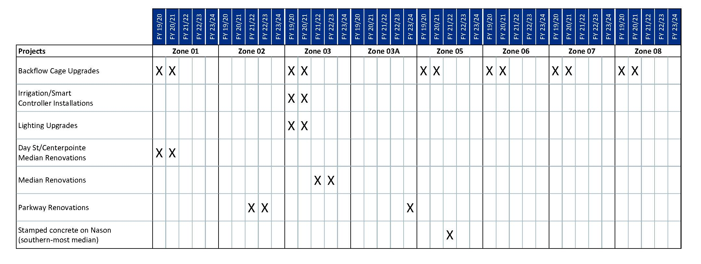

RESOLUTION JURAT

STATE OF CALIFORNIA )

COUNTY OF RIVERSIDE ) ss.

CITY OF MORENO VALLEY )

I, Pat Jacquez-Nares, Secretary of the Moreno Valley Community Services District, Moreno Valley, California do hereby certify that Resolution No. CSD 2019-__ was duly and regularly adopted by the Board of Directors of the Moreno Valley Community Services District at a regular meeting held on the 2nd day of April 2019, by the following vote:

AYES:

NOES:

ABSENT:

ABSTAIN:

(Boardmembers, Vice-President and President)

_________________________________
SECRETARY

(SEAL)

